Title: Temporal and Spatial Shifts in Gun Violence, Before and After a Historic Police Killing in Minneapolis

**Authors:** Ryan P. Larson1*, N. Jeanie Santaularia2, and Christopher Uggen1

**Affiliations:**

1University of Minnesota - Twin Cities, Department of Sociology.

2 University of North Carolina, Carolina Population Center.

**Abstract:** In 2020, the United States experienced major social unrest in response to police killings, as well as a rise in the homicide rate but not the overall crime rate. Although gun violence rose across the 50 states during the first year of the COVID-19 pandemic, Minnesota experienced the greatest rate of increase (1). This report uses Minnesota Hospital Association discharge data to consider the rate of firearm-related injuries occurring before and after the murder of George Floyd on May 25th, 2020. Interrupted time-series models reveal a significant post-murder increase in weekly firearm assault injuries, followed by a decrease, albeit not to pre-murder levels. Fixed-effects panel specifications corroborate this temporal pattern, while also documenting the spatial heterogeneity in the effect across Minneapolis, showing how more disadvantaged, historically Black communities experienced the brunt of the increase in firearm assaults. These temporal effects remain after adjusting for changes in police activity and pandemic-related restrictions, indicating that rising violence was not a simple byproduct of post-murder changes in police behavior or COVID-19 response. These findings show how the deleterious consequences of police killings and social unrest are disproportionately borne by underserved communities.

**One-Sentence Summary: Rates of firearm assaults increased after the police killing of George Floyd in Minneapolis, MN, primarily in more disadvantaged communities.**

**Main Text:**

In 2020, the United States experienced major social unrest and protests against racial injustice in response to several high-profile police killings of Black men and women. The murder of George Floyd, in particular, came to symbolize and represent the fatal consequences of longstanding structures of racial domination in the criminal justice system (2,3). These widely reported killings catalyzed the growing social movement #Blacklivesmatter, which brought attention to the long history and contemporary realities of police violence and brutality, particularly against Black people (4,5). With the highly publicized murder of Mr. Floyd on May 25th, 2020, these social tensions came to a head in Minneapolis, Minnesota, sparking sustained protests throughout the world. A widely reported spike in gun-related crime emerged after the murder, alongside claims that the rise in violence was due to changes in local police behavior (“depolicing”) in response to protest and social unrest (6,7), the COVID-19 pandemic, and a broad national increase in homicide (8).

**Background**

Research and public discourse in the aftermath of police violence has emphasized the temporal and spatial pattern of subsequent violent crime (9, 10). Studies following the police killings of civilians have focused on the so-called ‘Ferguson effect’ following the killing of Michael Brown in Ferguson, MO. Despite speculation that violent crime increased, particularly gun violence, there was no increase in homicides or other types of violent crime in St. Louis, Missouri (9, 10). After the unrest following Freddie Gray’s arrest and killing in Baltimore, however, shootings and homicides increased in the next three months (11). To date, the studies investigating these trends and associations have largely analyzed data reported directly from police departments. These data are limited, however, due to 1) selectivity associated with systemic racial biases and the overrepresentation of communities of color in police and court data; and 2) potential misclassification of gun violence due to changes in policing, and to the detection and categorization of crime events, in a time of disruption (12). Moreover, the willingness to report to the police is likely diminished in the aftermath of police violence, especially in communities that are already heavily policed and disproportionately impacted by gun violence (13). These points highlight the importance of alternative data sources to track gun violence that are independent of police. Although hospital data are not free of such biases, injury reports offer an independent and potentially more accurate source of information about gun violence.

In light of this background, the current analysis seeks to understand: 1) the temporal and spatial pattern of gun violence injuries in Minneapolis, before and after the police killing of Mr. Floyd; 2) whether the patterns of gun violence injuries mirror those observed after previous police killings in Ferguson, Baltimore or elsewhere; and 3) to the extent that we observe a “Minneapolis effect,” whether disadvantaged communities experienced the greatest change.

**Results**

***Temporal Pattern of Firearm Assault Injuries***

Figure 1 displays the weekly incidence of gun assault injuries from hospitals in Minneapolis from 2016-2020. We observe a sharp increase in the firearm assault injury rate from about .006 per 1,000 residents to a peak of .044 per 1,000 residents after the police killing of George Floyd, about a seven-fold increase. After an initial spike, the rate fell to levels consistent with the pre-killing period.

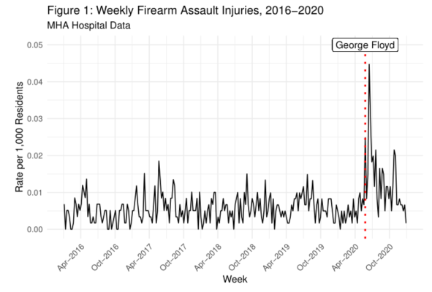

***Spatiotemporal Pattern of Firearm Assault Injuries***

After describing the temporal pattern in Figure 1, we next disaggregate the weekly data to local Zip Code Tabulation Areas (ZCTAs) to analyze the spatiotemporal variation in the rates of firearm assault. Figure 2 displays the firearm rates by Zip Code Tabulation Areas and period. The temporal pattern apparent in Figure 1 emerges, but only for certain ZCTAs. Specifically, areas already marked by higher gun violence in the pre-treatment period experienced greater change across the time periods as compared to ZCTAs with very low firearm assault incidence. The area surrounding George Floyd Square experienced an increase in firearm assault injuries in the three months following his death, but the red area representing the greatest spike is North Minneapolis, a historically Black community and a longstanding site of resistance to police violence and racial injustice.

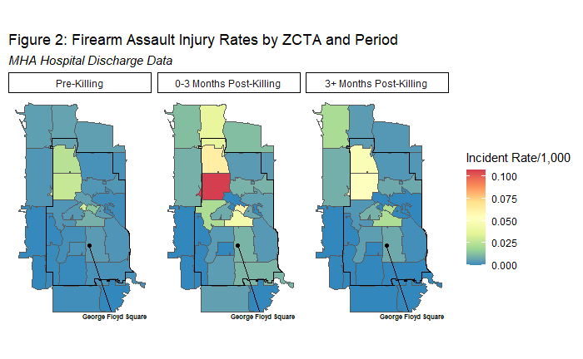

***Interrupted Time Series Models***

Table 1 presents interrupted time series models of the firearm assault injury rate in Minneapolis from 2016-2020. Each model includes a time indicator for each period[1] of analysis, as well as controls for seasonality and police behavior. Model 2 is estimated on disaggregated weekly Zip Code Tabulation Area data, and includes ZCTA fixed effects to account for time-constant unobserved heterogeneity such as local geographic features. Controlling for seasonal expectations, Model 1 indicates that the rate of firearm assault injuries rose in the three months after the killing (labeled Post-killing in the table), by an average of .014 firearm assault injuries per 1,000 residents. In the subsequent period (labeled Post killing 3 months), the rate declined .004, indicating that the rate did not return to the pre-killing baseline after the initial spike.

In Model 2 these results are corroborated using within-ZCTA comparisons, showing a .97 increase in firearm assault injury incidents per 1,000 residents in the immediate post-killing period, followed by a decline (-.35) in the following three months . After controlling for changes in police behavior in both models, the event time indicators remain largely unaltered in direction or magnitude, suggesting that changes in local policing did little to drive the increase in gun violence. If changes in police behavior had been a key driver of this post-killing increase, then the inclusion of police measures should have attenuated the post-killing effect, which we do not observe. This analysis provides only limited evidence of a “Minneapolis effect,” as the firearm assault injury rate increased above and beyond seasonal expectations, but this rise was not driven by changes in police behavior or by COVID-19-related state policy changes.

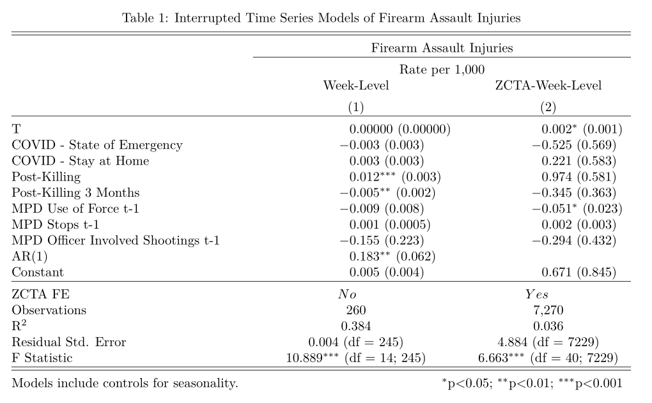

***Spatial Heterogeneity in Post-Killing Effects***

Figure 3 displays neighborhood-specific coefficients from a fixed-effects panel model. The model includes interaction terms between the ZCTA-fixed effects and the time indicators, which allows the time effects to vary by ZCTA.[2] In other words, the choropleths are shaded with the increase (red), or decrease (blue), in firearm assault rates, net of other factors, as compared to the preceding period. The figure shows that ZCTAs 55411, 55412, 55404, and 55415 – all historically Black and economically disadvantaged ZCTAs -- experienced significantly higher increases than other ZCTAs.[3] In addition, ZCTAs with significantly higher post-killing effects tended also to be in areas with the highest incidence of firearm assault injury in the pre-killing period, as indicated by the ZCTA main effects. These spatiotemporal patterns indicate that communities that experienced the largest increases in firearm assault injury incidence after the murder of Mr. Floyd were those *already experiencing* both higher levels of social disadvantage and firearm injury incidence. Importantly, the size of the firearm assault rate decreases in the final period are smaller than the increases in the three months immediately following the killing, indicating that rates did not return to pre-killing levels in the majority of ZCTAs that experienced an increase.

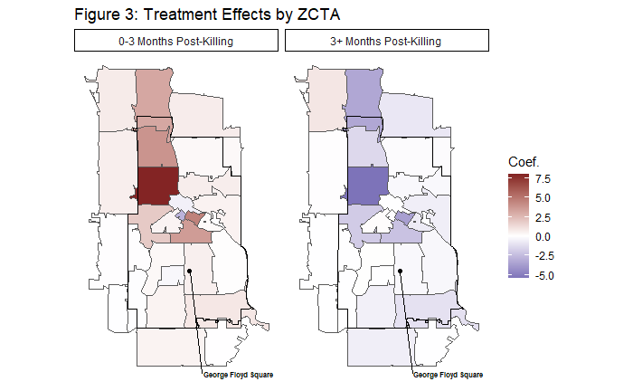

**Robustness and Persistence of Results**

Our analysis focuses on the 2020 calendar year when we have complete hospital data and information on key covariates. Although 2021 injury data are not yet available, we can provide descriptive information on the spatial and temporal pattern in Minneapolis homicides (and shootings?) to examine the robustness and persistence of patterns identified above. Figure 4 displays the weekly murder rates using Minneapolis Police Department data from 2016-2021.[4] Although the homicide rates are lower than the gun assault rates (as gun homicides are a small part of overall gun assaults), the post-killing spike observed in the hospital data is also present in the homicide data, with a jump from roughly .001 murders per 1,000 residents to .01 murders per 1,000 at its weekly post-killing peak, a ten-fold increase. Incorporating data from 2021 further contextualizes the potential longer-term impact of the killing, as weekly homicide rates did *not* return to their pre-killing levels in 2021, maintaining a mean weekly murder rate per 1,000 residents of about .003. This weekly rate is significantly higher than the pre-killing mean of .0001 (Welch’s t(60.3) = 5.8, p <.001).

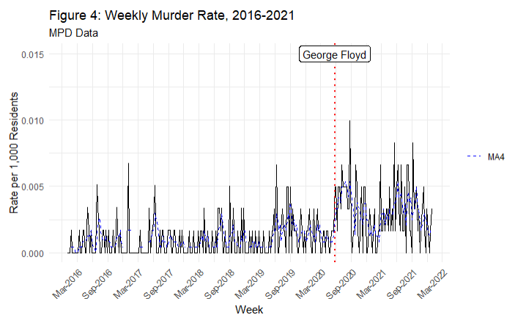

[figure 5 – spatial map, mirroring figure 2]

Figure 5 contextualizes the spatial findings using geolocated Minneapolis Police Department homicides into 2021. The spatial location of each MPD murder event is the incident ZCTA as opposed to the hospital clients’ residence ZCTA in the hospital administrative data, so the spatial rates here are not directly analogous. [5] Although the weekly homicide rates are lower than that of the gun assault incidence, we observe a similar spatial pattern in post-killing increases in homicides. Further, while we also see a similar decline in the 3+ months post-killing period from the initial three months post-killing with the inclusion of 2021 into this period, the weekly murder rates do *not* return to pre-killing levels for certain ZCTAs, indicating that, for some communities, the elevated rates of violence persisted into 2021.

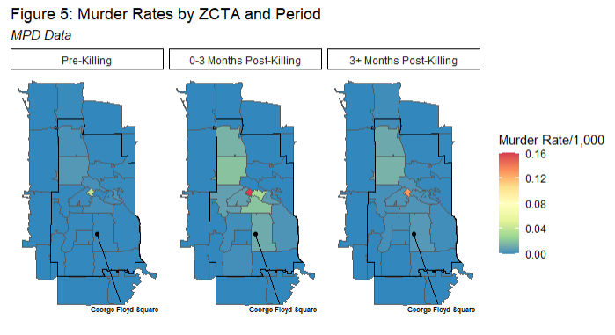

**Discussion**

We find that firearm assault injury rates spiked dramatically and then declined in Minneapolis after the murder of George Floyd by police, after statistically adjusting for seasonality, changes in police behavior, and COVID-19-related state policy changes. Further, our models indicate that changes in police behavior did not drive the temporal changes in gun assault injuries. These findings reveal a “Minneapolis effect,” wherein an extreme and high-profile police killing significantly altered the temporal pattern of firearm assault injuries. This finding is consistent with past studies of in cities such as Baltimore after the Freddie Gray police killing (11). The present study, however, adds important information to this literature by examining a measure of gun violence that is less prone to bias or selection concerns. In addition, our analysis shows that communities already experiencing higher levels of social disadvantage and firearm incidence had disproportionate increases in firearm assault injury after the murder of Mr. Floyd. These findings speak to the traumatizing effects of police violence and the short- and long-term consequences for communities, particularly Black communities (2). Further research is needed to elucidate these processes, but the pattern of findings is consistent with the idea that police violence impacts vulnerable communities by destabilizing social order and threatening public safety.

References and Notes

1. Ssentongo, P., Fronterre, C., Ssentongo, A.E. et al. Gun violence incidence during the COVID-19 pandemic is higher than before the pandemic in the United States. *Scientific Reports* 11, 20654 (2021).
2. Muller, C. “Exclusion and Exploitation: The Incarceration of Black Americans from Slavery to the Present.” *Science*, *374*(6565), 282-286 (2021).
3. Page, J., & Soss, J. “The Predatory Dimensions of Criminal Justice.” *Science*, *374*(6565), 291-294 (2021).
4. Nummi, J., Jennings, C., & Feagin, J. “# BlackLivesMatter: Innovative Black Resistance.” *Sociological Forum* 34: 1042-1064 (2019).
5. Edwards, F., Lee, H., & Esposito, M. “Risk of Being Killed by Police Use of Force in the United States by Age, Race–Ethnicity, and sex.” *Proceedings of the National Academy of Sciences*, 116 (34), 16793-16798 (2019).
6. Jany, Libor and Liz Sawyer. “Gun Violence Soars amid Crises of Health, Public Trust, Officer Reluctance.” *Star Tribune*, June 20 <https://www.startribune.com/surge-in-gun-violence-tests-minneapolis-leaders/571524202/> (2020).
7. Shjarback, J. A., Pyrooz, D. C., Wolfe, S. E., & Decker, S. H. “De-Policing and Crime in the Wake of Ferguson: Racialized Changes in the Quantity and Quality of Policing among Missouri Police Departments.” *Journal of Criminal Justice*, *50*: 42-52 (2017).
8. Federal Bureau of Investigation. “FBI Releases 2020 Crime Statistics”. Retrieved 9/29/2021 ( <https://www.fbi.gov/news/pressrel/press-releases/fbi-releases-2020-crime-statistics>) (2021).
9. Rosenfeld, R. “Ferguson and Police Use of Deadly Force.” *Missouri Law Review*, *80*, 1077 (2015).
10. Pyrooz, D. C., Decker, S. H., Wolfe, S. E., & Shjarback, J. A. “Was There a Ferguson Effect on Crime Rates in Large US Cities?.” *Journal of Criminal Justice*, *46*, 1-8 (2016).
11. Morgan, S. L., & Pally, J. “Ferguson, Gray, and Davis: An Analysis of Recorded Crime Incidents and Arrests in Baltimore City, March 2010 through December 2015.” Retrieved 9/29/2021 (<https://osf.io/preprints/socarxiv/nshme/>) (2016).
12. Wu, D. T., Moore, J. C., Bowen, D. A., Kollar, L. M. M., Mays, E. W., Simon, T. R., & Sumner, S. A. “Proportion of Violent Injuries Unreported to Law Enforcement.” *JAMA Internal Medicine*, 179(1), 111-112 (2019).
13. Desmond, M., Papachristos, A. V., & Kirk, D. S. “Police Violence and Citizen Crime Reporting in the Black Community. *American Sociological Review*, 81(5): 857-876 (2016).

**Acknowledgments:** Not Applicable.

**Funding:**

Minnesota Population Center  P2C HD041023 (NJS)

Interdisciplinary Population Health Science Training Program T32HD095134 (NJS)

**Author contributions:**

Conceptualization: RPL, NJS, CU

Data Curation: RPL, NJS

Formal analysis: RPL

Funding acquisition:

Investigation: RPL, NJS, CU

Methodology: RPL, NJS, CU

Project administration: RPL, NJS, CU

Resources: RPL, NJS

Software: RPL

Supervision: CU

Validation: RPL, NJS, CU

Visualization: RPL

Writing – original draft: RPL, NJS

Writing – review & editing: RPL, NJS, CU

**Competing interests:** Authors declare that they have no competing interests.

**Data and materials availability:** The majority of the data that support the findings of this study are readily available online, such as the American Community Survey, Minneapolis Police Department Data, Minnesota DNR Daily Weather Data, and Minneapolis School Calendars. However, the Minnesota Hospital Association data is restricted and cannot be publicly shared. However, requests for this data can be submitted (see supplementary materials for details). All code for analysis completed as a part of this study are also available in a GitHub repository (see supplementary materials for details).

Supplementary Materials

Materials and Methods

(Please delete before submission) Supplementary materials should be included in a separate supplementary materials file. A template for this file can be found at: <http://www.sciencemag.org/sites/default/files/Science_Supplementary_Materials_Word_template.docx>.

1. We construct linear time indicators at four key events in 2020: 1) the introduction of the Governor’s COVID-19 State of Emergency order (03/13/2020), 2) the introduction and conclusion of the Governor’s COVID-19 Stay at Home order (03/28/2020-05/28/2020), 3) the police killing of George Floyd (05/25/2020), and 4) three months following the police killing of George Floyd (08/25/2020).
2. Full model available upon request to the corresponding author.
3. A random effects specification with cross-level interactions indicates that the post-killing effect was significantly higher in ZCTAs with higher proportions of Black residents. Model is available upon request from the corresponding author.
4. A 4-week simple moving average (assuming equal weights across the window) is plotted on top of the weekly murder rates in Minneapolis to smooth out the variability present in the week-to-week homicide rates.
5. This is apparent in the spatially small ZCTA 55402 in downtown Minneapolis. The number of murders is high due to the confluence of people downtown, but the ZCTA has a relatively small residential denominator. This is in contrast to the gun assault rates in 55402, which measures the gun assault incidence for *residents* of 55402, as opposed to overall incidence in the ZCTA.